BSI.IT.10.C13 – Config Authentication – CPA (2026)
IT RCSA – Configuration Management
Item | Detail
Control | BSI.IT.10.C13 – Config Authentication (Heracles 50539552)
Risk | [BSI.IT.10.R3 PW Config] Unauthorized access to systems and data due to failure to enforce strong password configurations may result in data compromise, system and business disruptions, financial loss, and regulatory noncompliance. (High)
Owner / executor | Ian Rojo
Relevance / nature / frequency | Key Control / Hybrid / In every operation
Testing period | 07/05/2025 – 01/04/2026 (semi-annual) – tested as sustainability testing of the open Action Driver
Prepared by / reviewer | Edward Morfa (IT RCSA) / Amanda Munoz Henry (Testing Manager)
Evidence | Folder BSI.IT.10.C13 Config Authentication/Evidence – files start with their E-number. Screenshots in Evidence/Screenshots.

Control statement
[BSI.IT.10.C13 Config Authentication] In every operation, Infrastructure Engineering have configured strong authentication settings/policies for operating systems on premise to align with the Authentication and Authorization Standard. Exception to authentication configurations must be approved by the CISO.
Status today
Sustainability testing – Windows fixed; Linux not evidenced; AD stays open

Test script
There is no BSI test script for this control in the 2026 Test Plan. This one follows the SBNA / C10 scripts and the C7 / C8 format, adjusted for BSI. It is also in the testing workbook, tab 2_Test Script.
1. Obtain Evidence
Obtain the current Authentication and Authorization Standard, OS authentication configuration reports for in-scope on-premise servers, evidence of the settings applied by Infrastructure Engineering, and any CISO exception approvals.
2. Validate Report Completeness and Accuracy
Check the reports hold every setting the Standard asks for, and trace selected settings to the server (hostname and date on each export or screenshot).
3. Validate Population and Scope
Confirm the population covers all in-scope on-premise Windows and Linux servers. For sustainability testing, include every server raised in the 2025 exception.
4. Verify Control Execution
Check each sample's password and lockout settings (length, complexity, history, expiry, minimum age, lockout threshold / duration, idle timeout, Linux maxrepeat).
5. Validate Control Results
Compare settings to the Standard and the hardening guides and record deviations.
6. Verify Exception Handling
For deviations, check for a CISO-approved SEF exception.
7. Verify Escalation and Remediation
Check deviations were escalated, tracked and fixed; check AD mitigating actions.
8. Assess Risk Mitigation
Decide whether the settings keep weak passwords and open sessions off the servers.
9. Summarize Testing Coverage
Record population, samples, results, open items and the conclusion.
Evidence used
Ref | What it is
E01 | Authentication and Authorization Standard v13.0, approved 07/28/2026 – SUS.AAS.4.2.2.3-4.2.2.8 on p.10. The version in force for the period was not provided.
E02 | Windows Server Hardening Guide – 4.2 Account Lockout Policy (p.7), 2.3.7.3 machine inactivity limit (p.65)
E03 | Linux Red Hat Hardening Guide v3.0 – Local Ref 85-87 minlen, complexity, maxrepeat (p.16)
E04a-j | Windows security exports for the 10 servers raised in 2025
E05 | Linux screenshots 11/03/2026 – pwquality credit settings for 4 servers
E06 | SEF exceptions approved 07/01/2025 – 07/04/2026 – the file is empty
E07 | Coverage period calculation
E08 | WP2 C13 2025 (prior year)
E09 | 2025 exception form (Windows idle timeout; Linux maxrepeat)
Test Plan | 2026 Test Plan, tab Open ADs, row 196 – AD 005056BCA24E1FD0B4A6A1173BF00BA4

Testing period
C13 was rated Weak on 12/19/2025, so it moves to semi-annual testing (Testing Procedure 4.1.2). The 2025 period ended 07/04/2025, so the next one is 07/05/2025 – 01/04/2026 (E07). But the control has an open Action Driver (target 09/30/2026). While an AD is open, CDA and CPA cannot be done; the control is checked through sustainability testing once the fix is in (Testing Procedure 4.1.3 and 4.5). The AD itself plans that test (mitigating action 'Authentication Hardening Sustainability Testing', 09/30/2026).
What we did and what we found
1. Evidence obtained
We have the Authentication and Authorization Standard v13.0 (E01), both hardening guides (E02, E03), secedit exports for the 10 Windows servers raised in 2025 (E04a-j), Linux screenshots for 4 of the 5 Linux servers (E05), the SEF list (E06, empty), the 2025 exception form (E09) and the AD (Test Plan, Open ADs row 196).
Result: Partially completed.
Reference: E01-E09
Screenshot 1 – C13_S8_open_AD.png (Evidence/Screenshots)
2. Completeness and accuracy
All 10 exports are standard secedit output. Three carry the server name inside (SQL3, SWDB, FNAPP). MIA-DC-TOFS and MIADCCTXLIC01 are the same file byte for byte. Seven have no name or date inside. The values are the same on all 10, which fits a domain policy. The Linux screenshots show hostname and time (11/03/2026).
Result: Observation – ask for hostname / date on the 7 unnamed exports.
Reference: E04a-j (C13_S2); E05
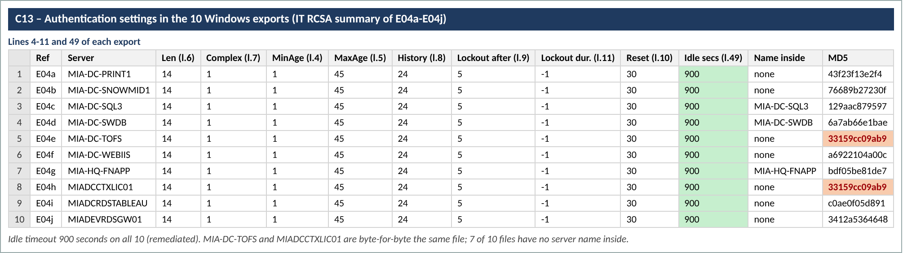
Screenshot 2 – C13_S2_export_summary.png (Evidence/Screenshots)
3. Population and sample
For sustainability we retested the full 2025 exception population: 10 Windows and 5 Linux servers (E09). Testing Procedure 4.5.1 lets us pick a period and samples that show the fix holds; for a central policy setting, the same servers plus the policy itself are enough. Mia-dc-selene was not provided.
Result: 15 servers in scope; 14 provided.
Reference: E09; Testing Procedure 4.5
4. Windows – the 2025 exception (idle timeout)
All 10 servers now have InactivityTimeoutSecs = 900 seconds (15 minutes) on line 49 of each export. The guide asks for 900 or fewer, not 0 (E02 p.65). In 2025 this setting was not defined.
Result: Pass 10/10 – fixed.
Reference: E04a-j line 49; E02 p.65
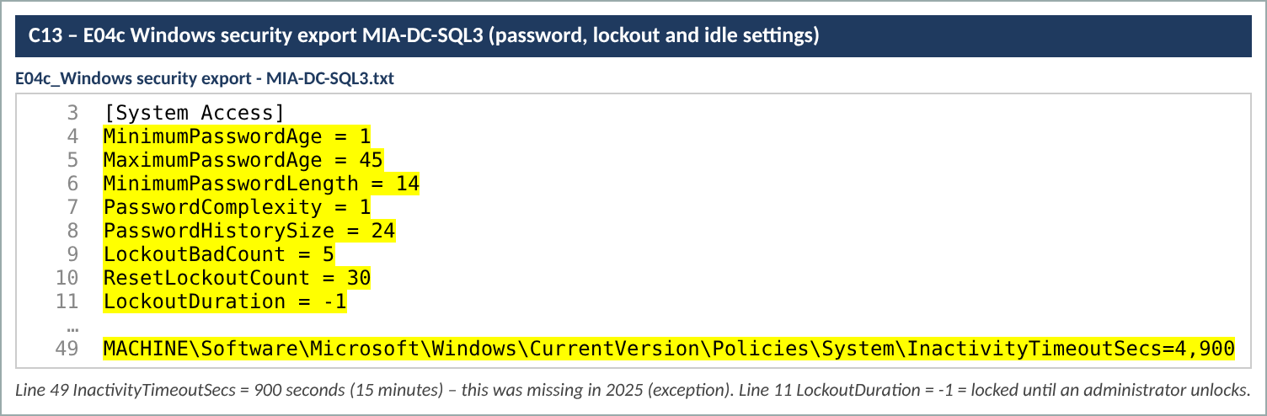
Screenshot 3 – C13_S1_SQL3_export.png (Evidence/Screenshots)
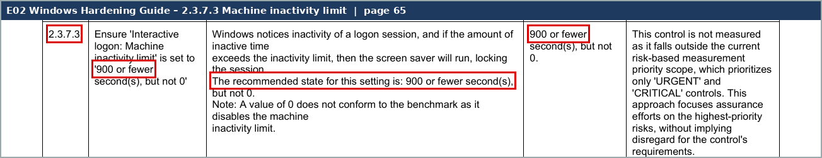
Screenshot 4 – C13_S6_Win_inactivity.png (Evidence/Screenshots)
4b. Windows – the rest of the settings
Length 14, complexity on, minimum age 1, maximum age 45, history 24, lockout after 5 tries, duration -1 (until an admin unlocks), reset after 30 minutes – all meet SUS.AAS.4.2.2.3-4.2.2.8 (E01 p.10). The lockout duration is stricter than the guide's 15 minutes.
Result: Pass 10/10.
Reference: E04a-j lines 4-11; E01 p.10; E02 p.7
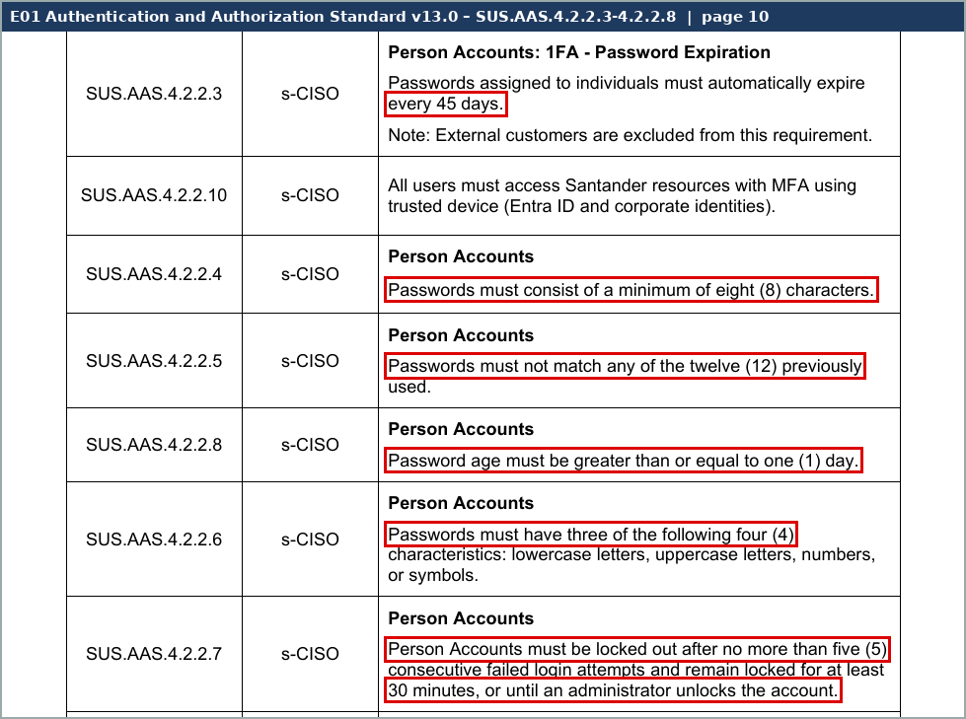
Screenshot 5 – C13_S4_AAS_passwords.png (Evidence/Screenshots)
4c. Linux – the 2025 exception (maxrepeat)
The screenshots for mia-dc-nb01-fs, miaecowas, miadevlxmq01 and mia-posit-app show dcredit, ucredit, lcredit and ocredit = -1. That meets the complexity rule (Ref 86) but maxrepeat is not in the screenshots. The command only greps the credit lines in /etc/security/pwquality.conf, and the guide expects maxrepeat = 3 in /etc/security/pwquality.conf.d/*.conf (Ref 87, E03 p.16). Nothing was provided for mia-dc-selene.
Result: Not evidenced 0/5 for maxrepeat; complexity Pass 4/4.
Reference: E05; E03 p.16
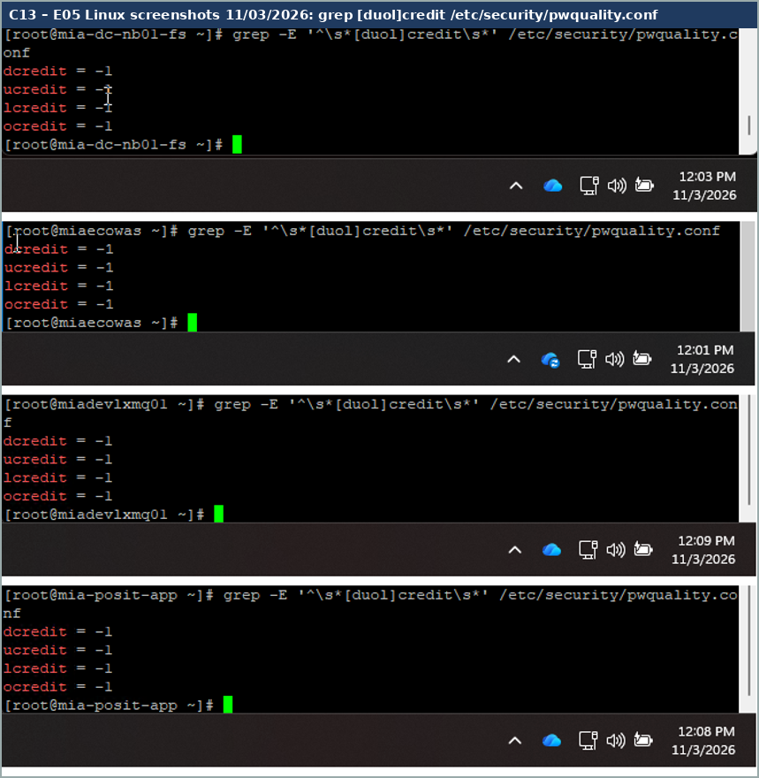
Screenshot 6 – C13_S3_Linux_pwquality.png (Evidence/Screenshots)
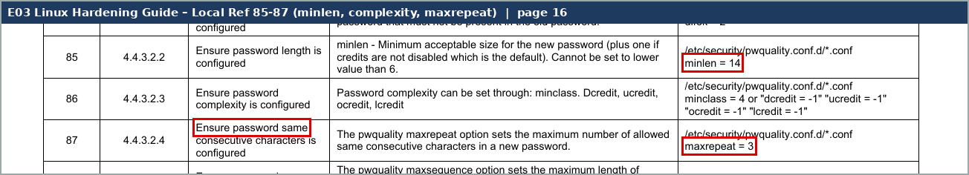
Screenshot 7 – C13_S7_Linux_maxrepeat.png (Evidence/Screenshots)
5. Results
Windows: the fix is in and holding. Linux: we can't confirm the fix.
Result: Mixed.
6. Exception handling
No SEF exceptions in the period (E06).
Result: Pass – none needed.
Reference: E06
7. Escalation and remediation
The AD mitigating action 'Remediate Authentication Hardening Deviations' was due 06/01/2026. Windows is done. Linux is not shown. The sustainability action is due 09/30/2026 and is now late.
Result: Linux remediation not evidenced.
Reference: C13_S8
8. Risk mitigation
Windows servers now lock idle sessions after 15 minutes. Until the Linux setting is shown, the 2025 Linux gap is still open.
Result: Partly mitigated.
9. Conclusion
Sustainability is not passed yet. Under Testing Procedure 4.5.2 the AD stays open until the Linux fix is shown. Once received and clean, the AD can be closed and C13 goes back to normal CPA testing for the next period.
Result: AD stays open – OI-1 to OI-4.
Reference: Testing Procedure 4.5.2
Sample results
# | Server | OS | 2025 exception | 2026 value | Other settings | Evidence | Result
1 | MIA-DC-PRINT1 | Windows | Idle timeout not set | 900 s (line 49) | Meet Standard | E04a | Pass
2 | MIA-DC-SNOWMID1 | Windows | Idle timeout not set | 900 s (line 49) | Meet Standard | E04b | Pass
3 | MIA-DC-SQL3 | Windows | Idle timeout not set | 900 s (line 49) | Meet Standard | E04c | Pass
4 | MIA-DC-SWDB | Windows | Idle timeout not set | 900 s (line 49) | Meet Standard | E04d | Pass
5 | MIA-DC-TOFS | Windows | Idle timeout not set | 900 s (line 49) | Meet Standard | E04e | Pass
6 | MIA-DC-WEBIIS | Windows | Idle timeout not set | 900 s (line 49) | Meet Standard | E04f | Pass
7 | MIA-HQ-FNAPP | Windows | Idle timeout not set | 900 s (line 49) | Meet Standard | E04g | Pass
8 | MIADCCTXLIC01 | Windows | Idle timeout not set | 900 s (line 49) | Meet Standard | E04h | Pass
9 | MIADCRDSTABLEAU | Windows | Idle timeout not set | 900 s (line 49) | Meet Standard | E04i | Pass
10 | MIADEVRDSGW01 | Windows | Idle timeout not set | 900 s (line 49) | Meet Standard | E04j | Pass
11 | mia-dc-nb01-fs | Linux | maxrepeat 0 | Not shown | credits -1 | E05 | Not evidenced
12 | miaecowas | Linux | maxrepeat 0 | Not shown | credits -1 | E05 | Not evidenced
13 | miadevlxmq01 | Linux | maxrepeat 0 | Not shown | credits -1 | E05 | Not evidenced
14 | mia-posit-app | Linux | maxrepeat 0 | Not shown | credits -1 | E05 | Not evidenced
15 | mia-dc-selene | Linux | maxrepeat 0 | Not provided | – | – | Not evidenced

Open items – what we need to finish
# | What we need | For | What it clears
OI-1 | For the 5 Linux servers: output of 'grep -E "maxrepeat|minlen|[duol]credit" /etc/security/pwquality.conf /etc/security/pwquality.conf.d/*.conf' with hostname and date on screen. | Linux fix (Ref 87) | Closes the Linux part of the AD.
OI-2 | Same servers: faillock (deny, unlock_time), pwhistory (remember) and /etc/login.defs (PASS_MAX_DAYS, PASS_MIN_DAYS). | Other Linux settings | Shows the rest of the Standard is met.
OI-3 | Hostname and date for the 7 Windows exports without a name inside (or 'gpresult /h' for each), and a fresh export for MIA-DC-TOFS or MIADCCTXLIC01 (same file today). | Accuracy | Ties each export to its server.
OI-4 | The Authentication and Authorization Standard version in force from 07/05/2025 to 01/04/2026, and the Qualys compliance scan for these servers. | Criteria / CDA Q5 | Confirms criteria and detection.

Sampling rationale
- Sustainability testing (Testing Procedure 4.5): full retest of the 15 servers in the 2025 exception (10 Windows, 5 Linux).
- The regular CPA for 07/05/2025 - 01/04/2026 is not done while the AD is open (Testing Procedure 4.1.3).
- Sample sizes: the control runs in every operation (each server build), mitigates a High inherent risk and is Hybrid, so medium assurance applies. For as-needed populations the RCSA sample size calculator prorates the sample on the population (RCSA Testing Procedure 4.4.2, Appendix H). Reference points from the minimum table: 151-250 items = 30, over 250 = 45. If the population is smaller than the sample, test all of it.
- A key attribute that fails fails the sample. For this frequency one exception in the original sample can be followed by an additional sample (Testing Procedure 4.4.8.2 table).

